SIZING GUIDELINES

Printable Dimensions (All sizing is by Inches unless otherwise stated)

Adult: 12”w x 16”h
  - TULTEX 202 AXS Garments: 10” x 13”

Youth: 9”w x 11”h
  - YL: 12”w x 16”h
  - YM: 10”w x 13”h

Toddler Tee: 7”w x 10”h

Infant Onesie: 4"w x 5”h

Adult Hoodie Front - 12”w x 10”h (This is to accommodate for the front pocket)
  - AXS 12”w x 8”h

Youth Hoodie Front: 10”w x 6”h
  - YXS: 8”w x 4.5”h

Tee Sleeve Print: 4”w x 4”h
  - YS: 3”w x 3”w

Adult Long Sleeve: 4”w x 14”h
  - Youth Long Sleeve: 4”w x 9”h

Left Crest and Locker Tags: 4”w x 4”h
  - YS 3” x 3”
  - Recommended not to do LCs on Toddler Tees/Onesies

DTF/Digital Ink: 12 x 16
  - YS 9 x 12
  - Can do oversized (14 x 18) but for in house purposes.

Set Up Types:

Adult - Adult only sizes, can include Youth Large sizes because YL=AS

Youth - Youth only sizes

Single - Adult and Youth sizes. Art is sized to fit the largest youth garment being ordered (see above).

Multiple - Adult and Youth sizes. Adult art is set to Adult specifications, and Youth art is set to Youth specifications.

COMMON GARMENT CODES:

202
235
320
291
340
Rabbit Skins 3321

SCREEN PRINTING SPECIFICATIONS:

2pt strokes (positive line)
2pt knockouts (negative line)
12pt Text, but still needs to meet to 2pt minimum

Placement Standards:

Front -2.5” down 2 grid squares from bottom of collar
Back - 3” down down, 4 grid squares from bottom of collar
Locker Tag - 1” from collar, 1 grid square from bottom of collar

Short Sleeve - 2” from bottom of sleeve, if art is taller than wide, center on sleeve between top and bottom
Long Sleeve: Vertical, center in middle of sleeve
Cuff Print: 2” up from the cuff
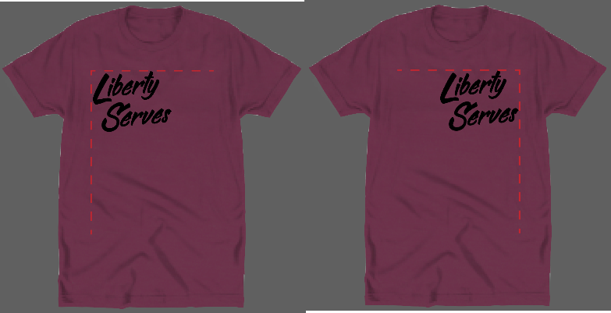
Hip Print: 2” in from side hem and 2” up from bottom hem
Right, left aligned art: Create guide for respective garment size and align correlating side

Placement Standards cont’:

Circular Art on front of Tees
The reasoning for this is that the larger the art, the higher chance it will warp when pulled off press, and circles are very noticeable with this.
- Adult: 9 - 10in
- Youth: 8 - 19in
- Can go to max Adult/Youth if requested from the client
- Circles on back of garment can go to max Adult/Youth size

Assorted Standards:

- Transparency Masks must be Spot Black or Spot White

- All text must be Outlined in the Client Mock Up. Keep a live version in the art board. Always Always, keep a live version of the art somewhere on your art board. Your peers will thank you if they have to do your revisions.

- Gradients in Adobe Illustrator must be set to CMYK
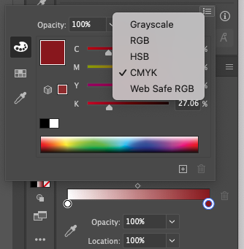

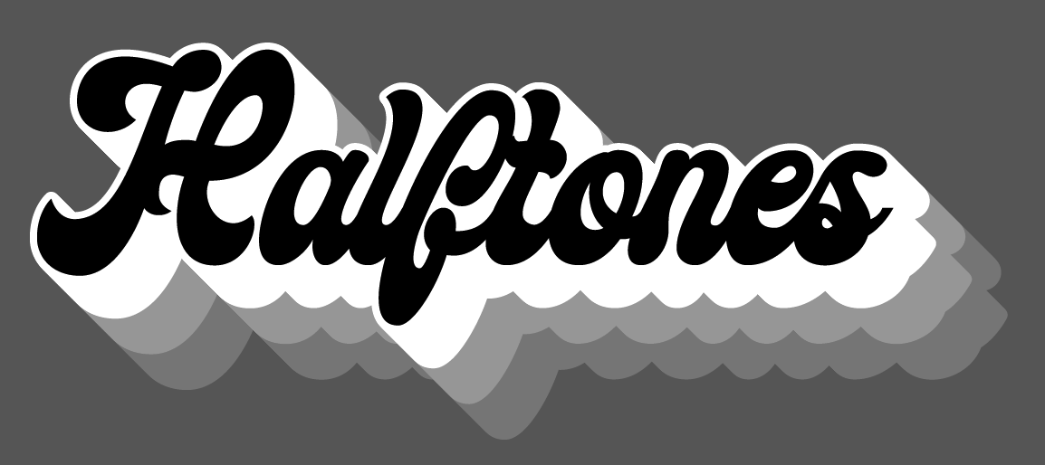

Halftones: Max halftone opacity is 50%. If there are several halftones, the halftones should be done in increments of 15-20%.Ex: 50%, 30%, 15%
- Text should never be halftone. If the artwork has drop shadows, halftones can be used as shown below.
- Halftones can only be layered over shirt color. It cannot lay other other inks.
- 100% opacity Text should have a t-shirt trap if they are layered on top of the same color halftone.
  - A Tee shirt trap is a 2pt stroke of the shirt color the art is going on.
- All halftones must be grouped with the same opacity.

